|  |  |
| --- | --- |
| **Project Name** | Smart Waste Management System For Metropolitan Cities |
| **Team ID** | PNT2022TMID20896 |

Data Flow Diagram:

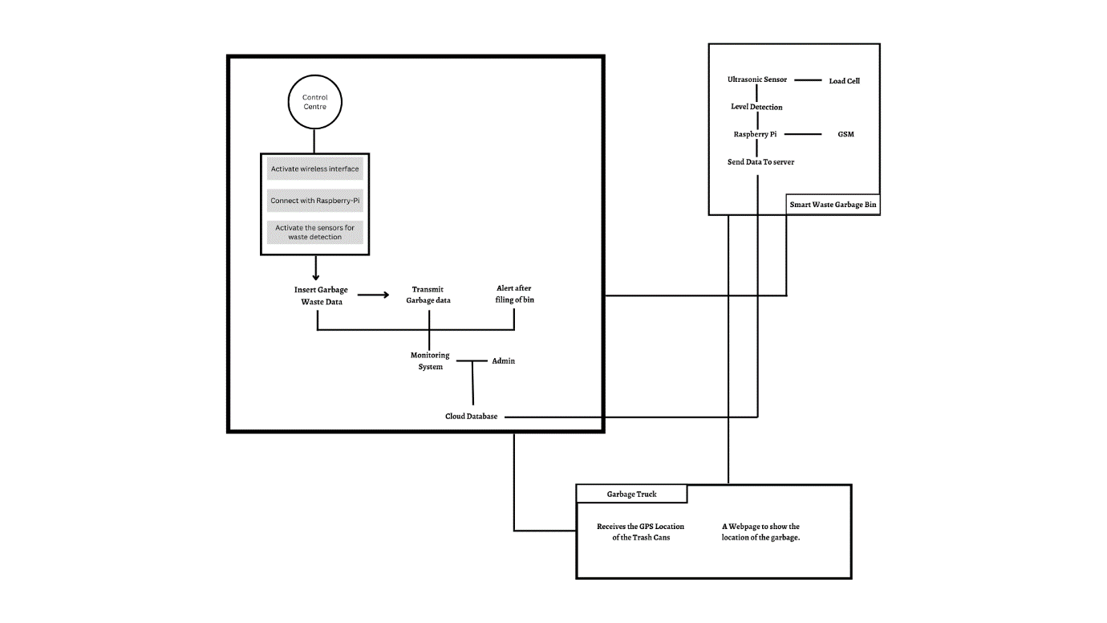

User Story:

Use the below template to list all the user stories for the product.

| **User Type** | **Functional Requirement (Epic)** | **User Story Number** | **User Story / Task** | **Acceptance criteria** | **Priority** | **Release** |
| --- | --- | --- | --- | --- | --- | --- |
| Admin | Login | USN-1 | Manages the Operators i.e., Collectors and other users.  Also Monitors the garbage bin levels and monitors. | Can Manage a webpage. | High | Sprint-3 |
| Truck Driver | Login | USN-2 | Follow the route given by the system to collect trash. | Can drive safely and properly. | Medium | Sprint-2 |
| Garbage collector | Login | USN-3 | Collect the trash and load it into the truck safely and without any harm done to the garbage as well as themselves. | Can Collect the trash and put them into the truck. And also be punctual and safe while doing so. | High | Sprint-2 |
| Municipality | Login | USN-4 | Has to check the progress on the application and make sure there are no issues. Should also make people aware of the safe and proper ways to dispose trash. | Keep check on the progress. | Medium | Sprint-1 |